21019821_Ngô Trung Kiên_tuần 3
Flexbox cơ bản:
Header - Category Chips - Book Grid
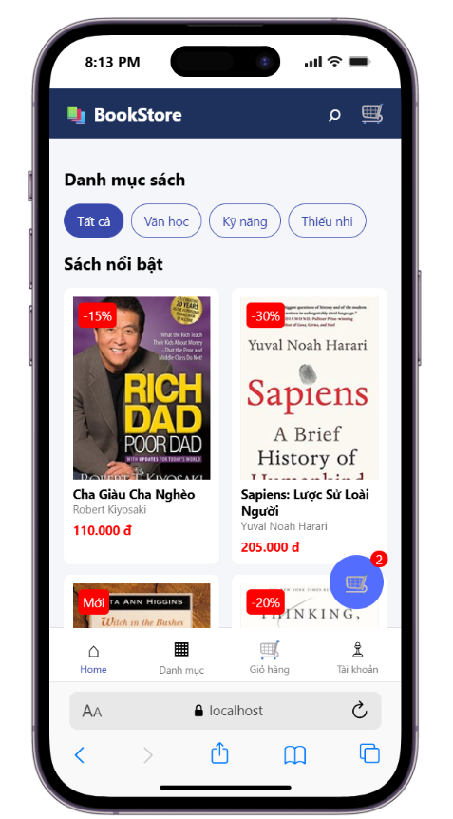

Book Card ngang:
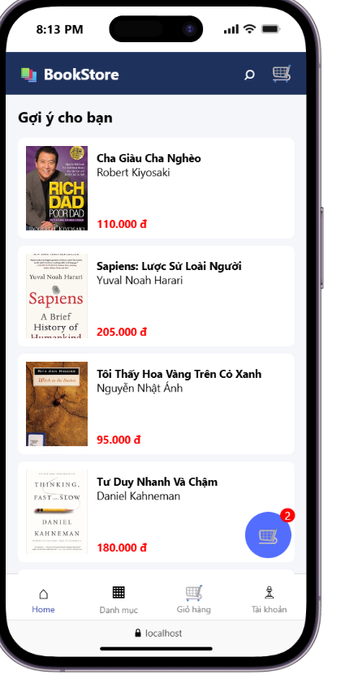

Badge - Floating Cart:
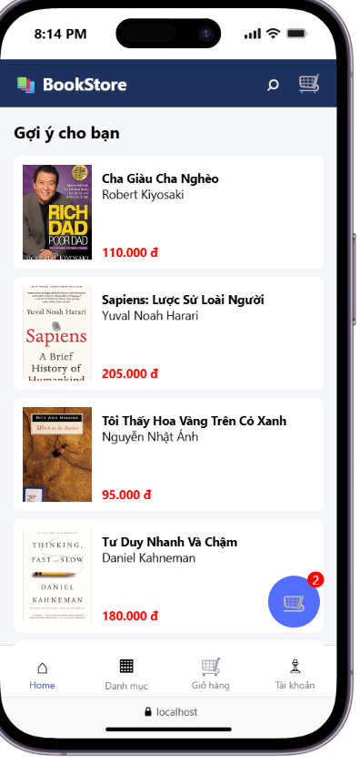

Chrome:
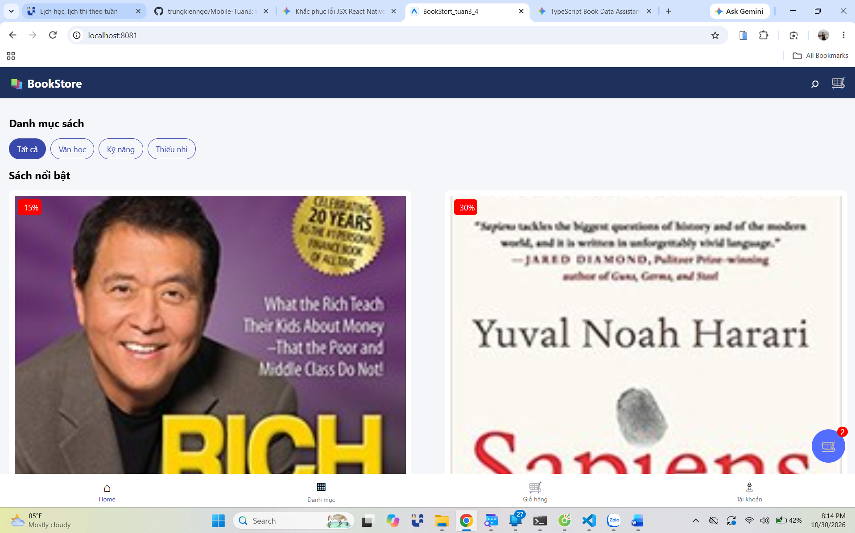

VS code:


